rr-r.t....-.::=========~--- ----- ---
..

• I
54 2. Statistical Learning

(b) What is our prediction with K = 1? Why? (c) What is our prediction with K = 3? Why?
(cl) If the Bayes decision boundary in this problem is highly non• linear, then would we expect the best value for K to be large or small? Why?

Applied

8. This exercise relates to the College data set, which can be found in the file College.csv. It contains number of variables for 777 different universities and colleges in the US. The variables are
a

• Private : Public/private indicator
• Apps : Number of applications received
• Accept : Number of applicants accepted
• Enroll : Number of new students enrolled
• Top0perc : New students from top 10% of high school class
• Top25perc : New students from top 25 % of high school class
• F. Undergrad : Number of full-time undergraduates
• P.Undergrad : Number of part-time undergraduates
• Outstate : Out-of-state tuition
• Room.Board : Room and board costs
• Books : Estimated book costs
• Personal : Estimated personal spending
• PhD : Percent of faculty with Ph.D.'s
• Terminal : Percent of faculty with terminal degree
• S. F. Ratio : Student/faculty ratio
• perc. alumni : Percent of alumni who donate
Expend :Instructionalexpenditureper student
l
• Grad.Rate : Graduation rate

Before reading the data into R, it can be viewed in Excel or a text editor.

(a) Use the read.csvO) function to read the data into R. Call the loaded data college. Make sure that you have the directory set to the correct location for the data.
(b) Look at the data using the fix0 function. You should notice that the first column is just the name of each university. We don't really want R to treat this as data. However, it may be handy to have these names for later. Try the following commands:
2.4 Exercises 55

> rownames (college)=college[,1]
> fir(college)

You should see that there is now a row. names column with the name of each university recorded. This means that R has given each row a name corresponding to the appropriate university. R will not try to perform calculations on the row names. However, we still need to eliminate the first column in the data where the names are stored. Try

> college=college[,-1]
> fix(college)

Now you should see that the first data column is Private. Note l
that another column labeled row. names now appears before the i
Private column. However, this is not a data column but rather .J
the name that R is giving to each row.
(c) i. Use the summ ary O function to produce a numerical summary of the variables in the data set.
ii. Use the pairs function to produce a scatterplot matrix: of the first ten columns or variables of the data. Recall that you can reference the first ten columns of a matrix A using A[, 1: 10].
111. Use the plot O function to produce side-by-side boxplots of
Outstate versus Private.
lV. Create a, new qualitative variable, called Elite, by binning the Top10perc variable. We are going to divide universities into two groups based on whether or not the proportion of students coming from the top 10 % of their high school classes exceeds 50 %.

> Elite=rep("No",nro(college)) \
I
> Elite[college$Top!Operc >50]=" Yes"
·E
> Elite=as.factor(Elite) I
> .- co 11 e g e=d at a.frame ( co 11 e g e,E 1 it e )
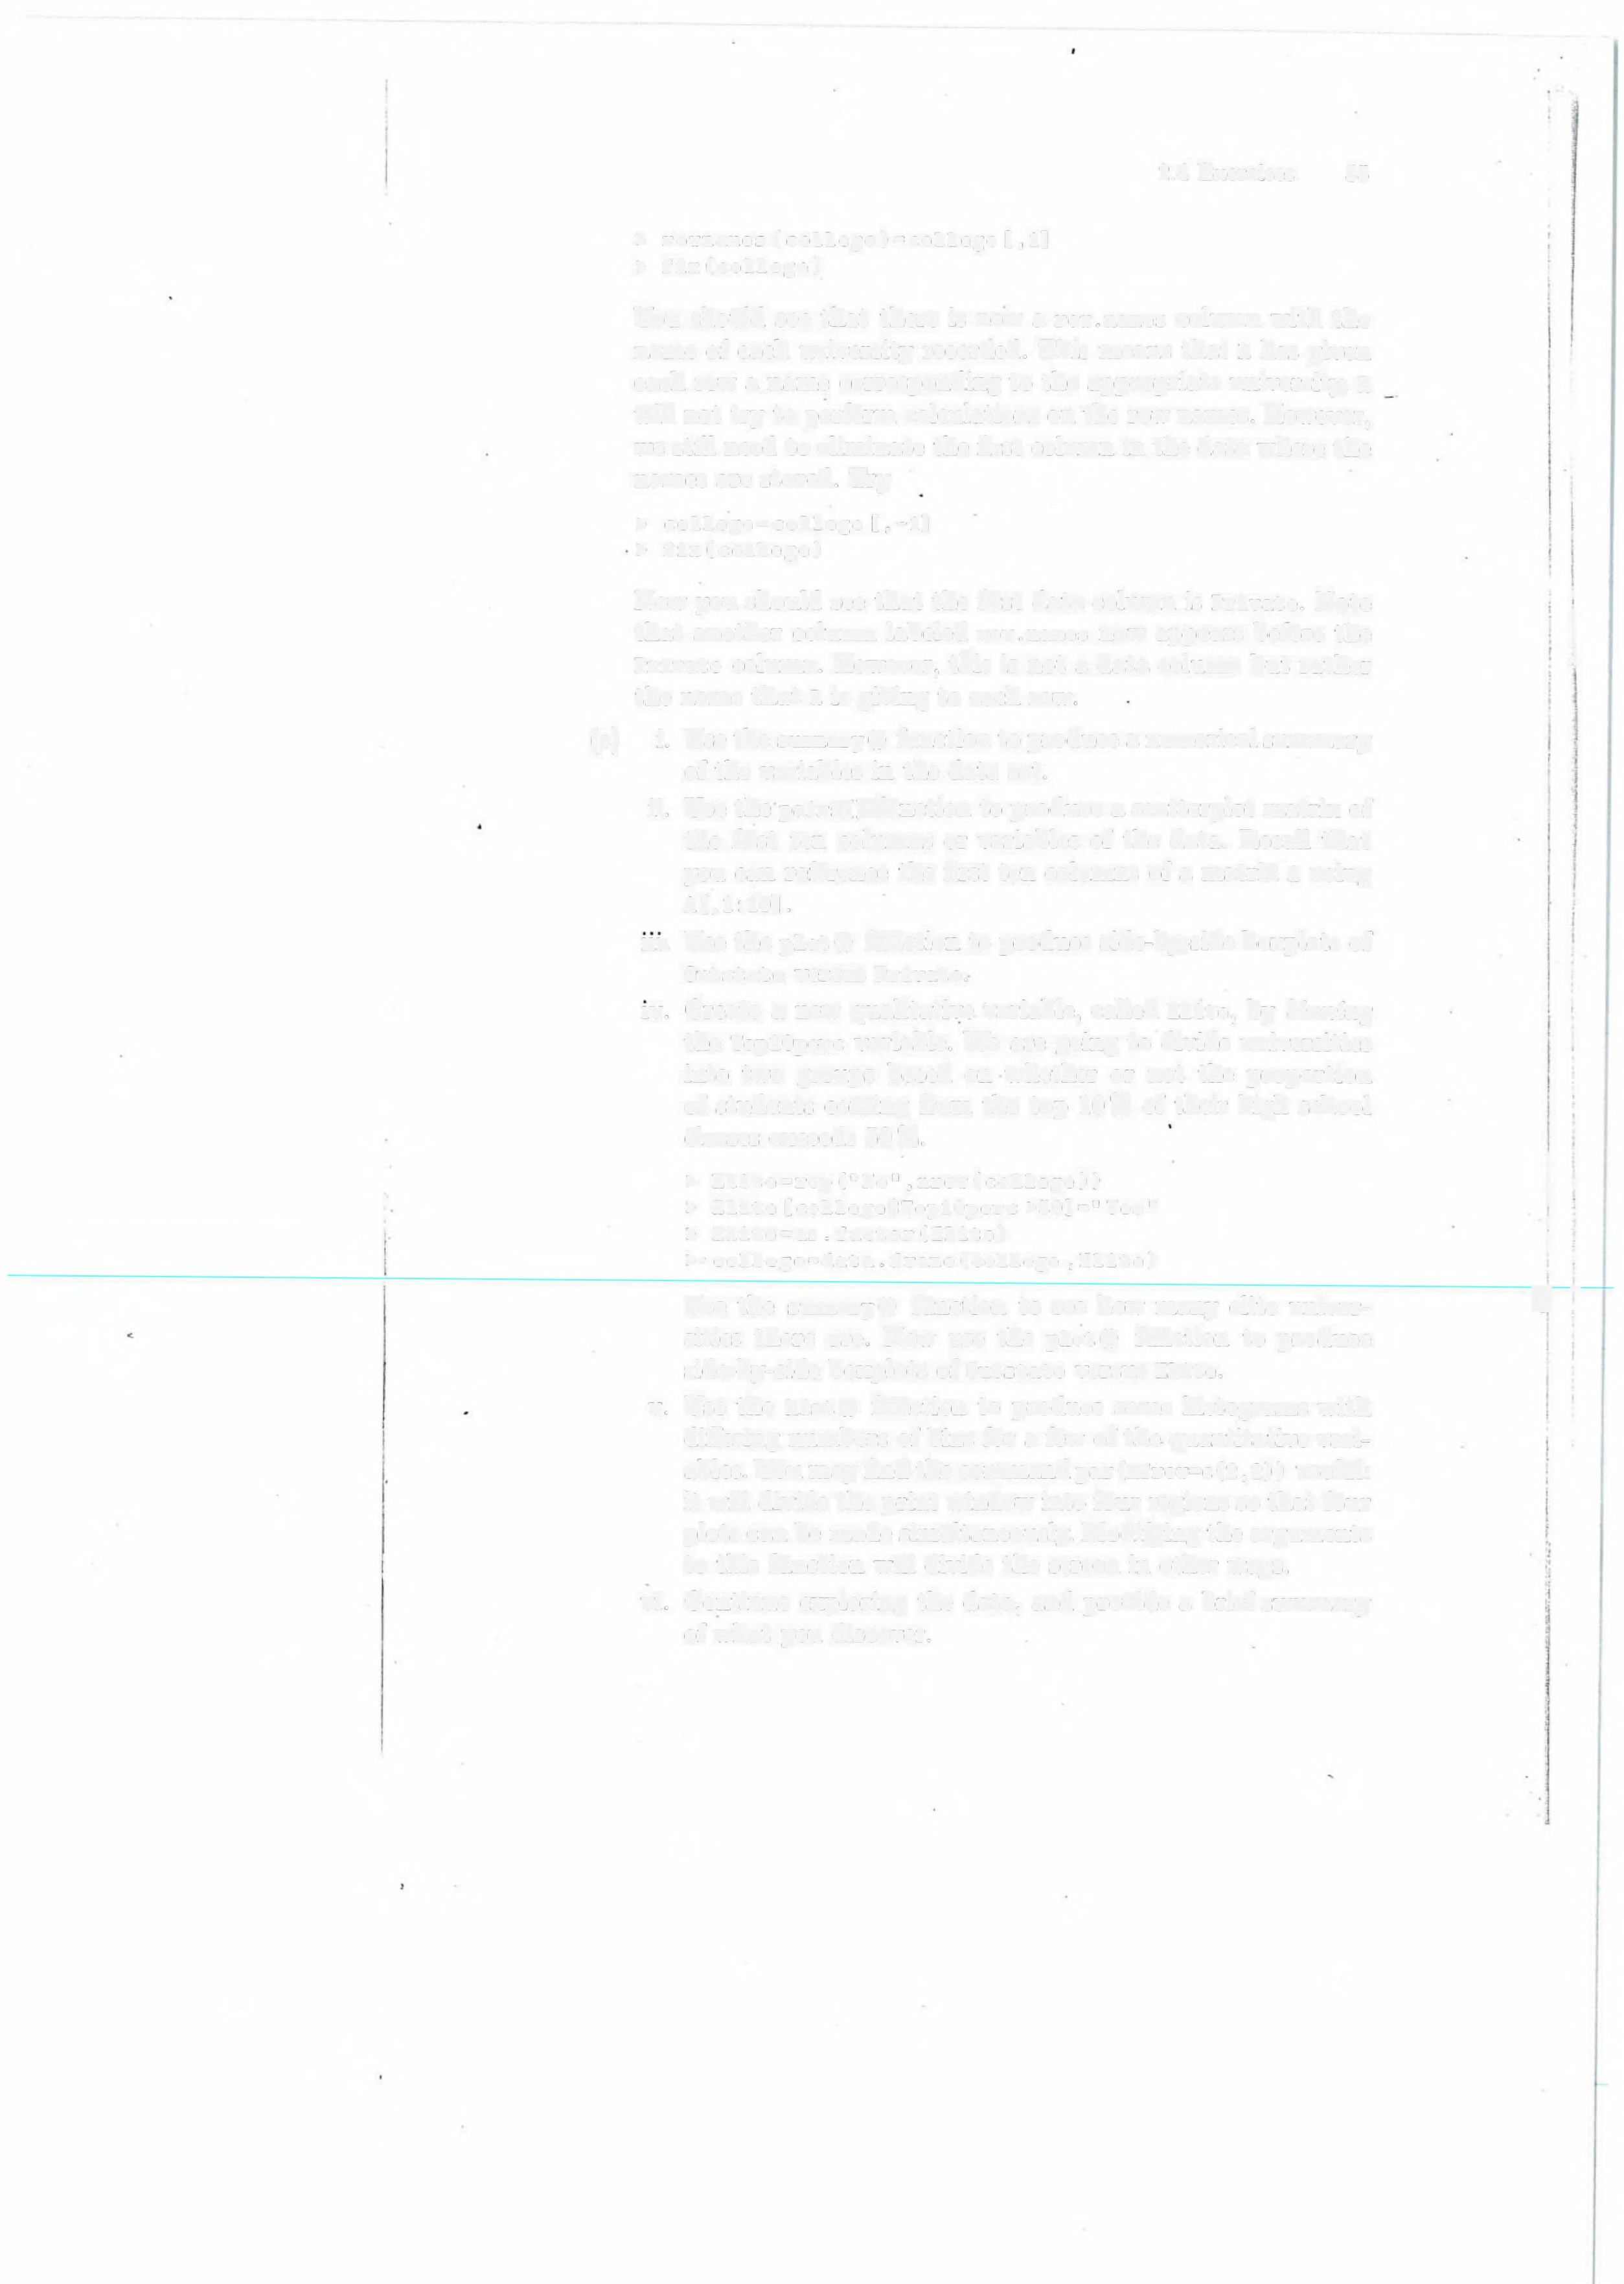
Use the summ aryO function to see how many elite univer• sities there are. Now use the plot O function to produce side-by-side boxplots of Outstate versus Elite.
v. Use the hist O function to produce some histograms with differing numbers of bins for a few of the quantitative vari• ables. You may find the command par(frow=c(2,2)) useful: it will divide the print window into four regions so that four plots can be made simultaneously. Modifying the arguments to this function will divide the screen in other ways.
vi. Continue exploring the data, and provide a brief summary of what you discover.
·J -
56 2. Statistical Learning

9. This exercise involves the Auto data set studied in the lab. Make sure that the missing values have been removed from the data.

(a) Which of the predictors are quantitative, and which are quali•
tative?
(b) What is the range of each quantitative predictor? You can an•
swer this using the range O function.
(c) What is the mean and standard deviation of each quantitative predictor?
(d) Now remove the 10th through 85th observations. What is the range, mean, and standard deviation of each predictor in the subset of the data that remains?
(e) Using the full data set, investigate the predictors graphically, using scatterplots or other tools of your choice. Create some plots highlighting the relationships among the predictors. Comment on your findings.
(f) Suppose that we wish to predict gas mileage (mpg) on the basis of the other variables. Do your plots suggest that any of the other variables might be useful in predicting mpg? Justify your answer.

10. This exercise involves the Boston housing data set.

(a) To begin, load in the Boston data set. The Boston data set is part of the MASS library in R.
> library (MASS)

Now the data set is contained in the object Boston.

> Boston

Read about the data set:

> ?Boston

How many rows are in this data set? How many columns? What do the rows and columns represent?
(b) Make some pairwise scatterplots of the predictors (columns) in this data set. Describe your findings.
(c) Are any of the predictors associated with per capita crime rate?
If so, explain the relationship.
(cl) Do any of the suburbs of Boston appear to have particularly high crime rates? Tax rates? Pupil-teacher ratios? Comment on the range of each predictor.
(e) How many of the suburbs in this data set bound the Charles river?

range0
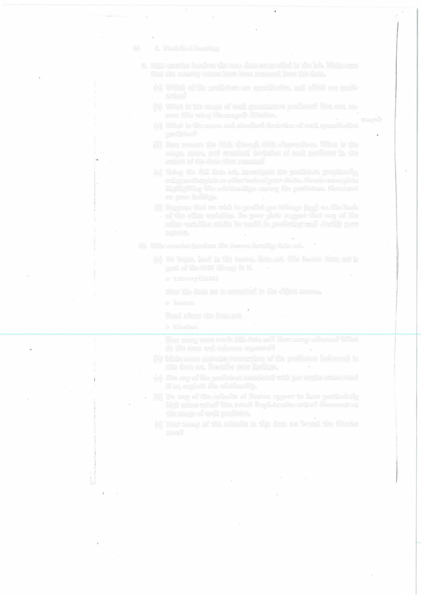

'i
e!
2.4 Exercises 57

(f) What is the median pupil-teacher ratio among the towns in this data set?
(g) Which suburb of Boston has lowest median value of owner• occupied homes? What are the values of the other predictors for that suburb, and how do those values compare to the overall ranges for those predictors? Comment on yow- findings.
(h) In this data set, how many of the suburbs average more than seven rooms per dwelling? More than eight rooms per dwelling? Comment on the suburbs that average more than eight rooms per dwelling.

